CS561 ASSIGNMENT REPORT

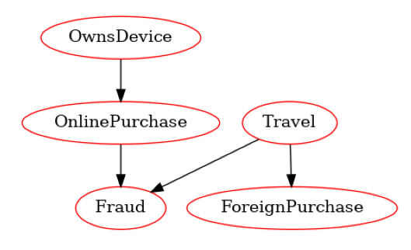
Assignment-1
I have assumed the following Bayseian Network:
The notations are same as the question. I have considered that the online purchase depends on owning a device; foreign purchase depends on Traveling abroad; and Fraud depends on both Travelling abroad and online purchase.

Conditional dependency tables:
1) Since OD and T doesnt have any parents their corresponding tables will just have their probabilities when the variables are true and false.
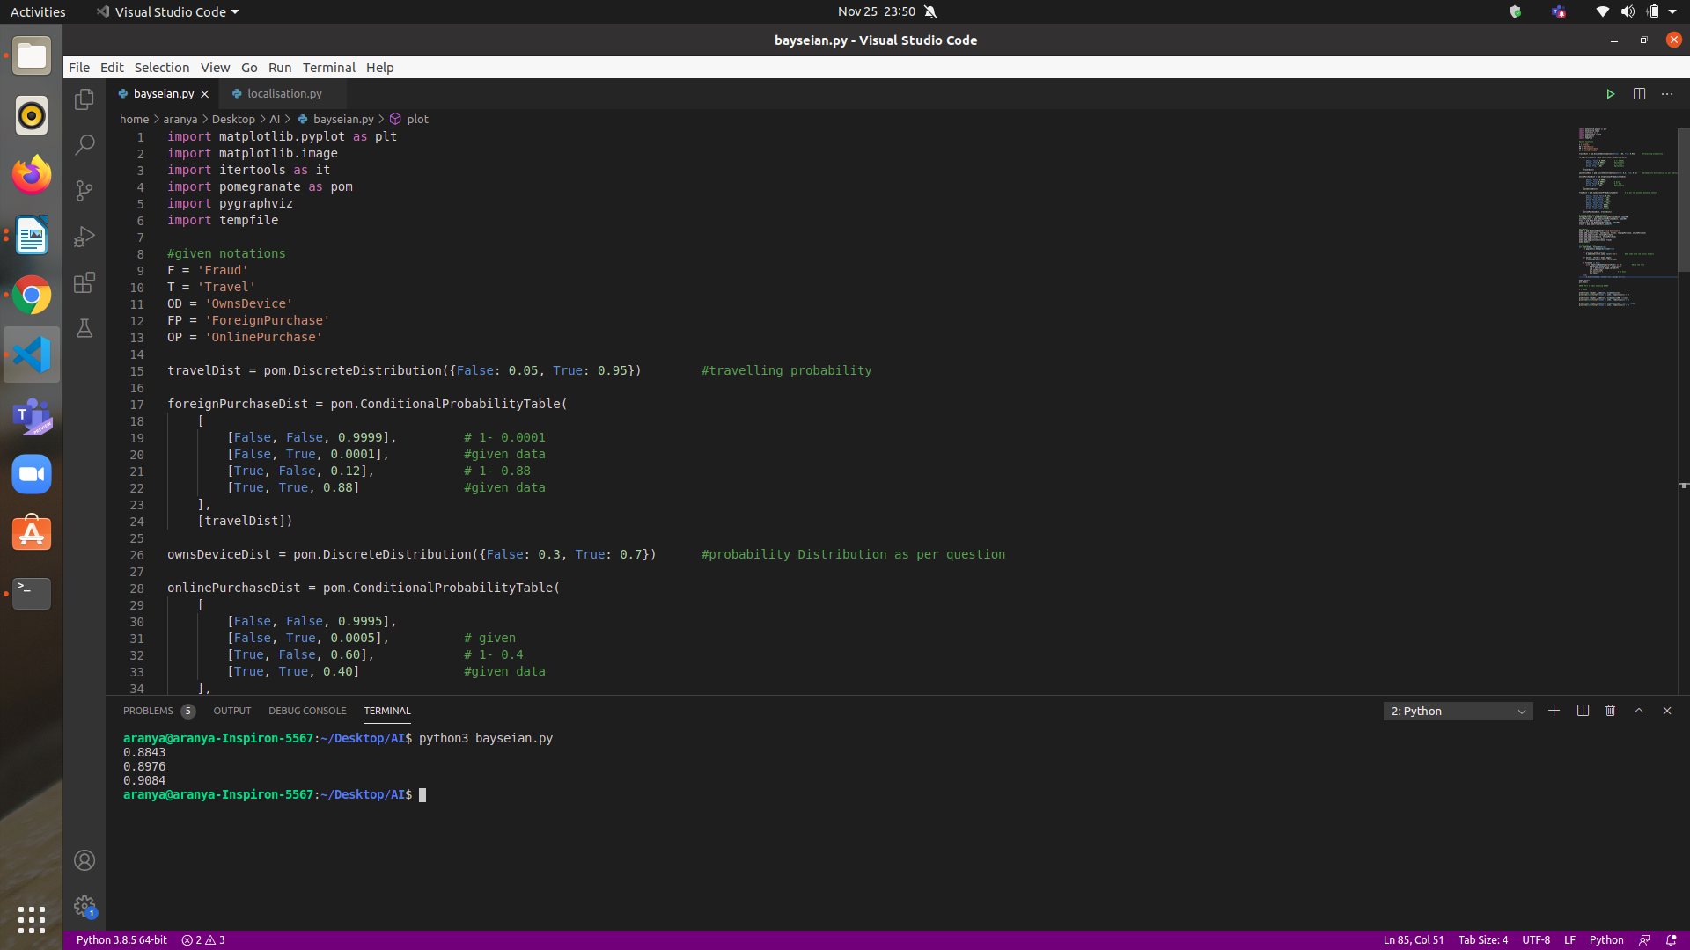

2) The following table is for OP|OD. The left column corresponds to OP, middle column corresponds to OD and right column corresponds to P(OP|OD) :
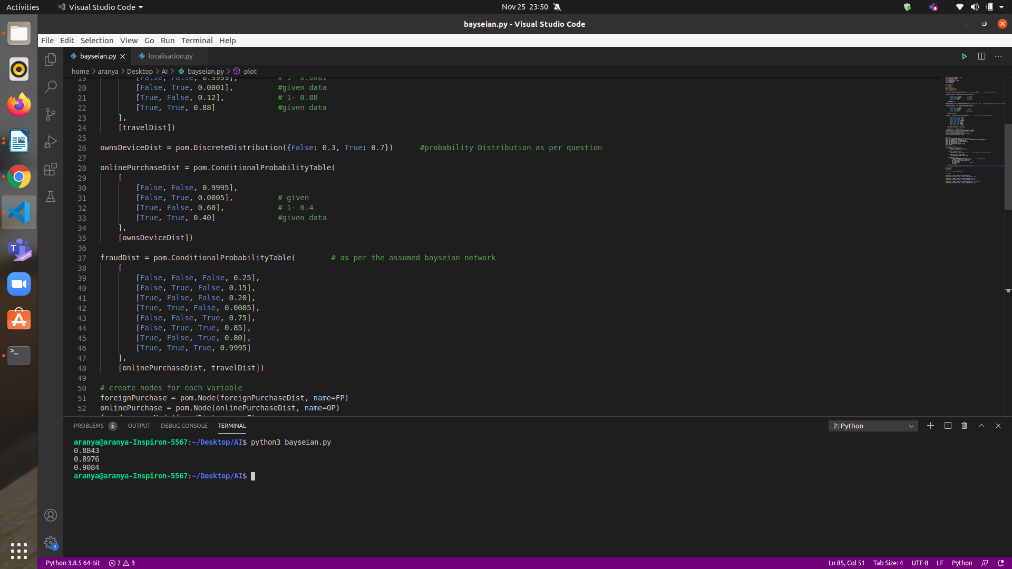

The following corresponds to F given T and OP. The columns in order are for F, T, OP , P(F|T,OP) respectively:

DEPENDANCIES

1) Fraud(F) Depends on Online Purchase(OP) and Travel(T)
2) Order Purchase (OP) depends on Own Device (OD)
3) Foreign purchase(FP) depends on Travel(T)
4) Travel(T) and Owns Device(OD) are independent

